2/6/2026
Shekhar Podutwar
2/6/2026
AWS Configuration Management Using Ansible
AWS Configuration with Ansible

Contents

Document Version History……………………………….…………………………………………….1
Introduction…………………….…………………………………………………………………………….2
Objectives…………………….………………………..….………………………………………………….3
Tools & Technologies Used…………………………………………………………………………….4
Architecture Overview ………………………………………………………………………………….5
Step-by-Step Implementation …………………………………..………………………………….6

Document Version History

Version Number | Date Modified | Author | Changes
Draft | 06/6/2026 | Shekhar | Draft Version

Introduction
This project focuses on configuring and managing AWS infrastructure using Ansible, an open-source automation and configuration management tool. The objective was to establish an Ansible Control Node and configure multiple AWS EC2 instances as managed hosts. Through SSH-based communication, Ansible was used to automate server configuration, software installation, and administrative tasks across multiple servers.
The project demonstrated how Ansible simplifies infrastructure management by eliminating repetitive manual tasks and enabling centralized control of cloud resources. This implementation provided hands-on experience in Infrastructure Automation, Configuration Management, and Cloud Administration using AWS.
Objectives

- Set up and configure Ansible in an AWS environment.
- Create and manage AWS EC2 instances for Ansible automation.
- Configure Ansible Control Node and Managed Nodes.
- Establish secure SSH communication between nodes.
- Create and manage Ansible inventory files.
- Execute Ad-hoc commands for remote server management.
- Develop and run Ansible Playbooks for task automation.
- Automate software installation and system configuration.
- Reduce manual administration efforts through automation.
- Gain practical experience in Configuration Management and Infrastructure as Code (IaC)
Tools and Technologies

| Category | Tools / Technologies
| ---------------------------------- | --------------------------------- |
Cloud Platform | AWS (Amazon Web Services)
Compute Service | Amazon EC2
Automation Tool | Ansible
Operating System | Amazon Linux / Ubuntu Linux
Remote Access | SSH, PuTTY
Programming/Scripting | YAML, Bash Shell Scripting
Configuration Management | Ansible Playbooks
Inventory Management | Ansible Inventory File
Security | AWS Security Groups, SSH Key Pair
Version Control | Git, GitHub
Architecture Overview
↓ ↓
Managed Host 1 Managed Host 2
(AWS EC2) (AWS EC2)
↓ ↓
Automated Configuration & Management

Workflow
- Launch AWS EC2 instances.
- Configure one instance as the Ansible Control Node.
- Configure remaining instances as Managed Nodes.
- Establish passwordless SSH authentication using key pairs.
- Create Ansible inventory file containing managed host details.
- Verify connectivity using Ansible ping module.
- Create and run Ansible Playbooks for automation tasks.
- Monitor successful execution and configuration updates.

Step-by-Step Implementation

Step 1. Create a three Instance
- Log in to the AWS Management Console.
- Open the EC2 Dashboard.
- Click Launch Instance and create the following instances:
- Control-Node
- Manage-Host1
- Manage-Host2
- Configure the instances:
- AMI: Amazon Linux 2
- Instance Type: t3.micro
- Create or select the following key pairs:
- control-node-keypair
- manage-host1-keypair
- manage-host2-keypair

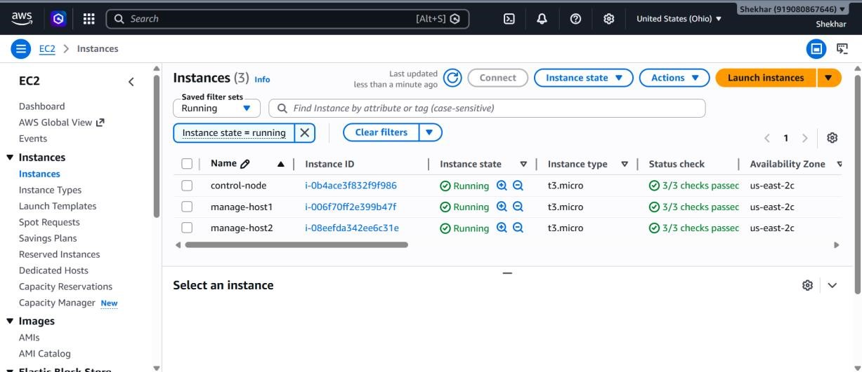

Step 2: Connect to Instances Using PuTTY
- Use PuTTYgen to convert the downloaded .pem files into .ppk format if required.
- Open PuTTY.
- Connect to the following instances:
- Control-Node
- Manage-Host1
- Manage-Host2
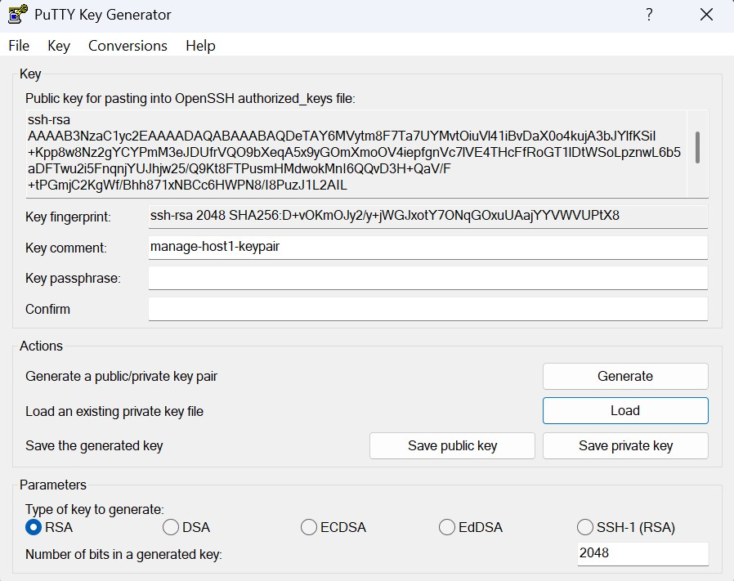

Step 3. Create Key Files on the Control Node
- Go to home directory Cd /home/ec2-user
- Create a two file
  - Vim manage-host1-keypair.pem
- Open file and past manage –host1-keypair.pem data
- Save (:wq!)
- Check permission (ls –l)
- Change permission to 400 using chmod command
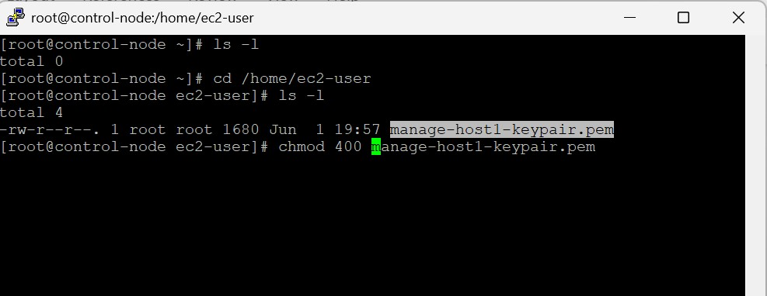
- Again, Create a file
- Vim manage-host-keypair.pem
- Open file and past manage –host-keypair.pem data
- Save (:wq!)
- Check permission (ls –l)
- Change permission to 400 using chmod command
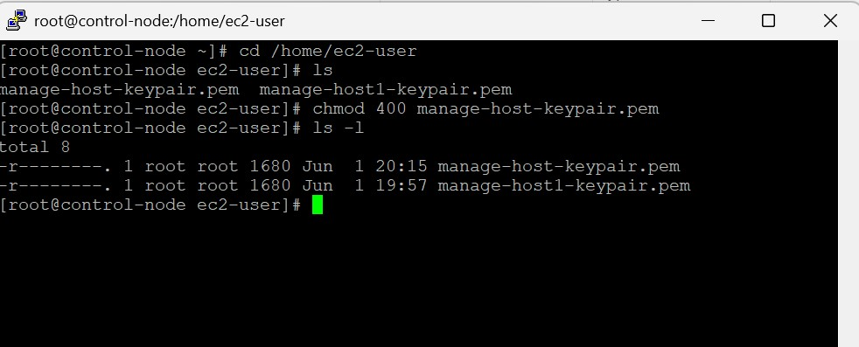

Step 4. Create the Ansible Inventory File
- Add all manage node entry into host's file
  - (vim /etc/ansible/hosts) and save
- [webservers]
- host2 ansible_host=private_ip_of_2nd_machine ansible_user=ec2-user ansible_ssh_private_key_file=/home/ec2-user/keypair2.pem
- host3 ansible_host=private_ip_of_3rd_machine ansible_user=ec2-user ansible_ssh_private_key_file=/home/ec2-user/keypair3.pem
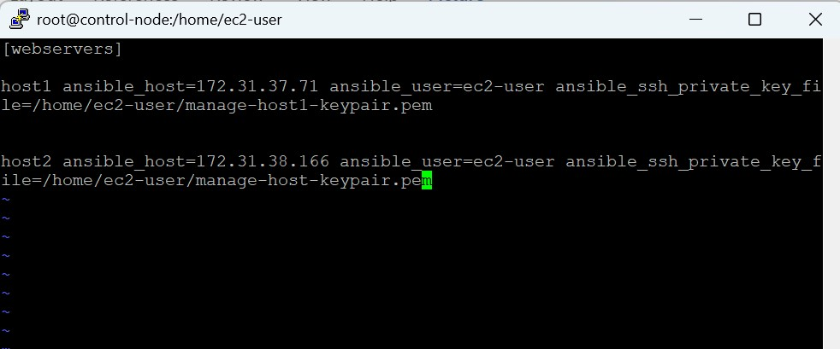

Step 5. Verify Connectivity
- For that use command
- (Ansible –m ping host1)
- To check all (ansible –m ping all)
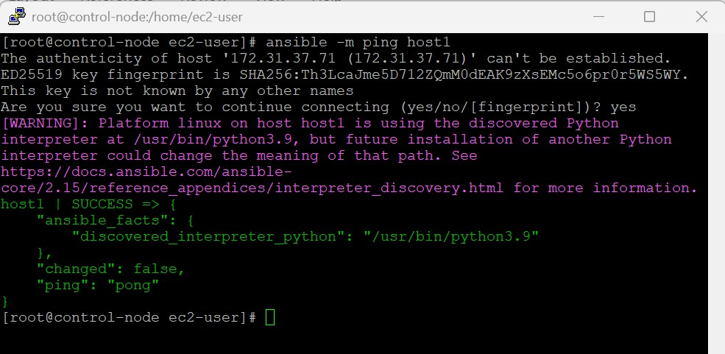

Step 6. Execute Commands from the Control Node
- Ansible all –m command –a “sudo yum install –y tree”
- To check packages, install in manage node (yum list tree)
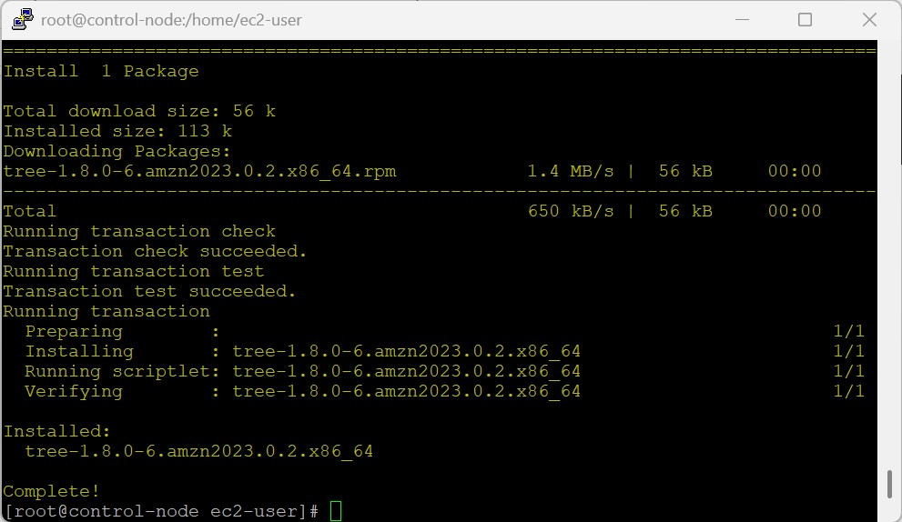
Conclusion
This project successfully demonstrated the implementation of Ansible for configuration management and infrastructure automation within an AWS environment. By establishing a Control Node and multiple Managed Nodes, repetitive administrative tasks were automated through Ansible Playbooks and Ad-hoc commands. The project improved operational efficiency, ensured configuration consistency, and reduced manual effort in server management. It also provided practical experience in AWS cloud administration, Ansible automation, Infrastructure as Code (IaC), and DevOps best practices, making infrastructure management more scalable, reliable, and efficient.

